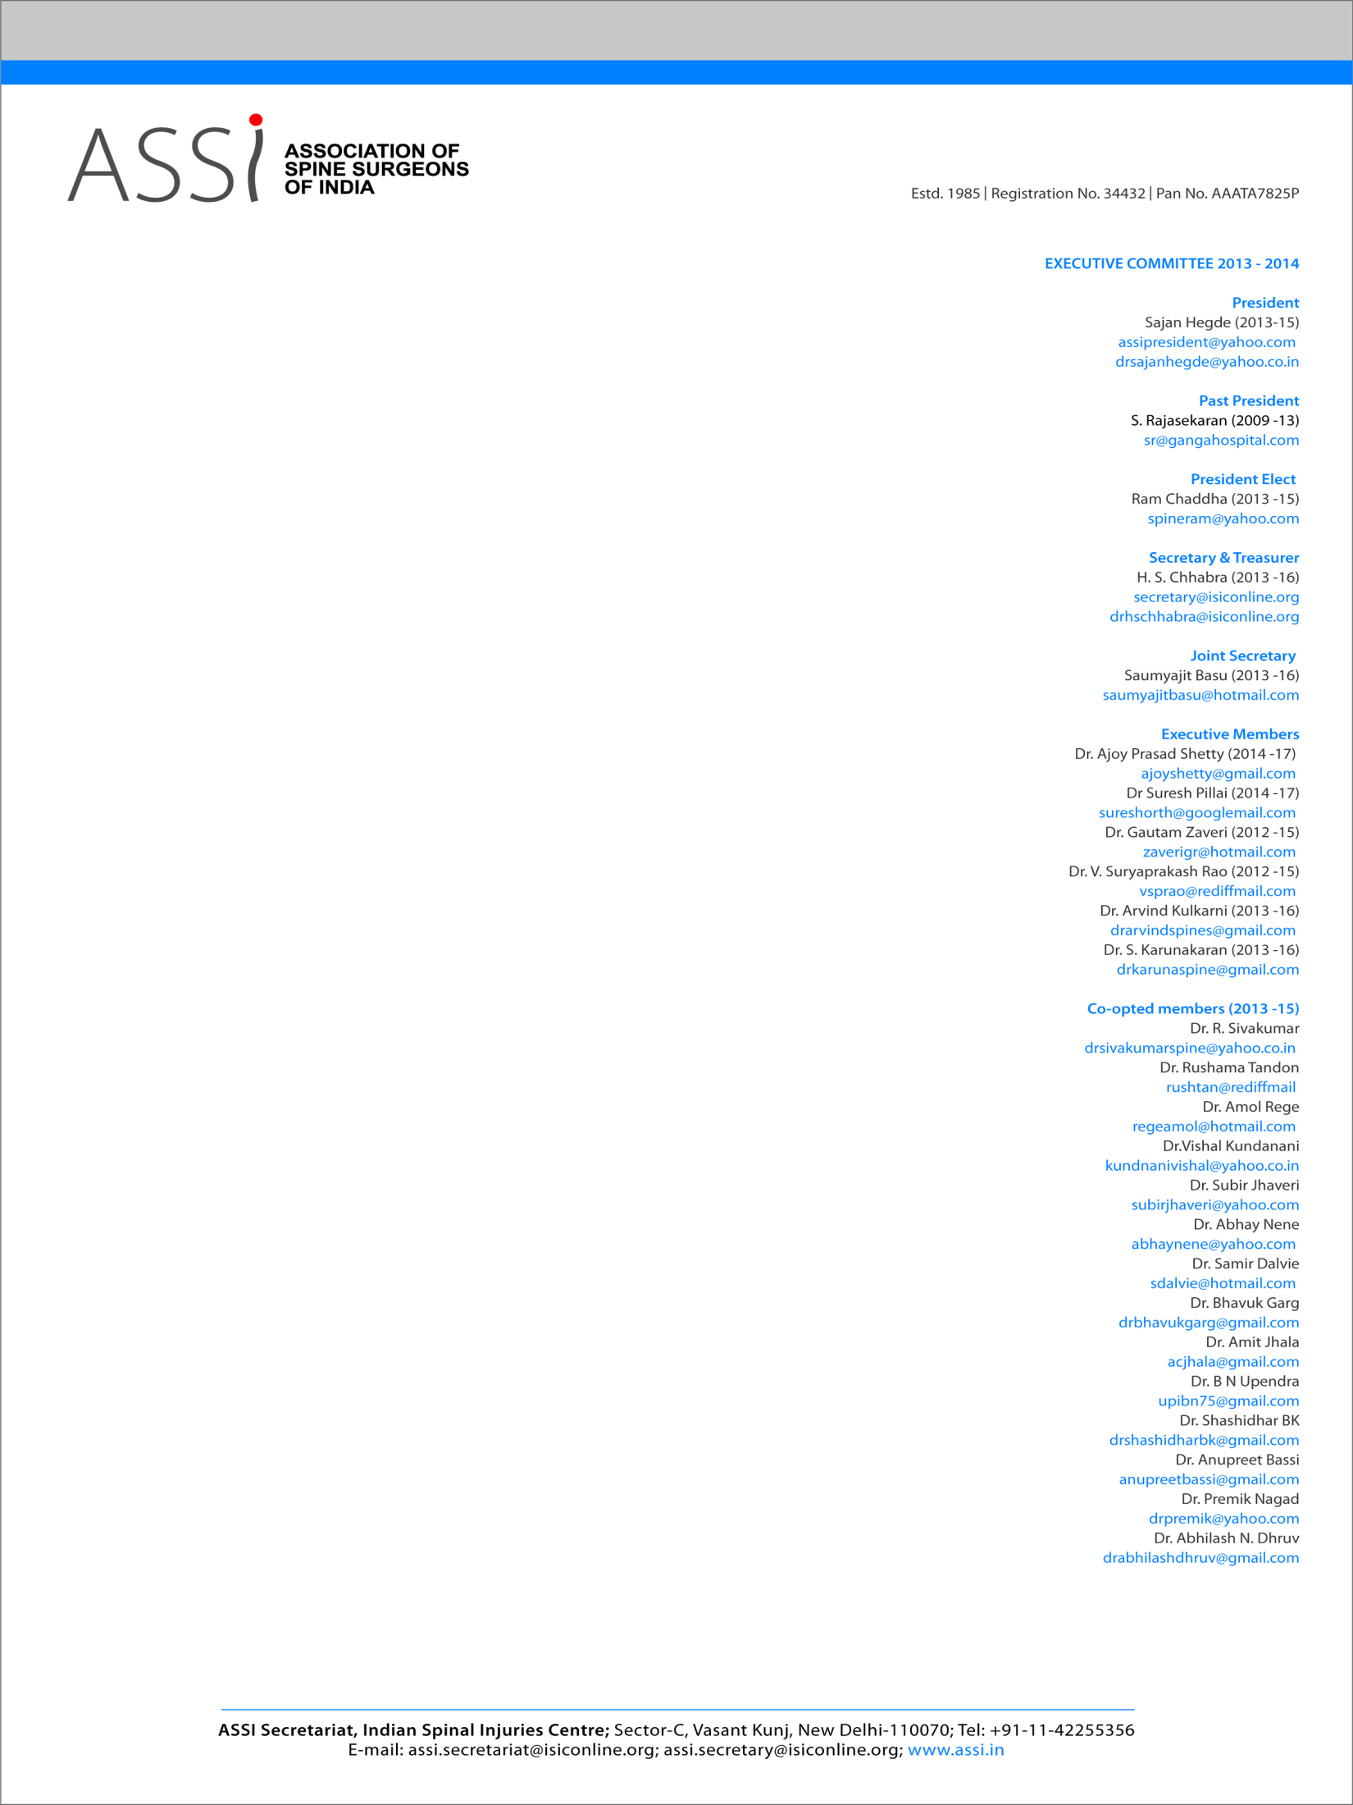
NOMINATION FORM
ASSI election for year 2026
Association of Spine Surgeons of India (ASSI) Election-2026
Nomination Form
(Photocopy can also be used)

Name of the Member: …………………………..……………………………………………………….…………….…..
Post for which contesting : ……………………………………………..…….………………………………………….
Membership No. / Year : ………………………………………………………………………………………………….
Address : ……..……………….……………………………………………….……………………………………………….. ……………………………………………..…………………………………………………..…………………………………………………………………….……… ……………………………………………….……………………………..…..….………
Mobile No. : ……………………….………..….. E-mail Address: ……………………….……………………………

Proposed by : Seconded by:

Name : ……………………….……………….…..….. Name: ……………….……………….……….…..…...
Membership No.: ………………………………… Membership No.: ………………………………….
Signature : ……………………………………………. Signature: …………..………………….……………

Consent of Contestant

I hereby agree to contest for the post of…………………………………………….……..of the ASSI. If elected I will serve the Association to the best of my ability. I shall not use any unfair means for my election.

Date : ………………………
Place : ……………………… Signature of Contestant

